Company Dash repository and source viewer
Document 32 of the Nexora learning guides
Source snapshot 14 October 2026 at 06:41 UTC
Find Nexora source and documents and understand which files enter an isolated snapshot.

Recognise the screen and its scope
Open http://127.0.0.1:8000/#knowledge. Company Dash uses loopback port 8000 and hash navigation. Open its separate repository in VS Code before Ctrl+P. The source library uses company-dash as a project label, not a Nexora folder.
This guide covers Repository refresh; File and code search; Source reader; Excluded and linked paths; Snapshot fingerprints.
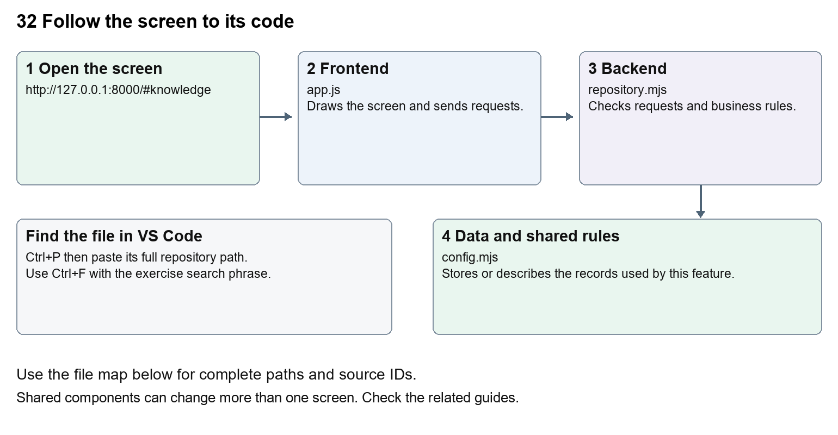
The diagram shows the file roles. The full paths below are what you paste into Ctrl+P.

Find the files in VS Code
Role | File and source ID | What it does
Screen | S0696 app.js | Main UI or route for this topic
Server | S0708 repository.mjs | Endpoints or server rules
Data | S0704 config.mjs | Data shape or persistence structure

Screen S0696
public/app.js
Server S0708
server/repository.mjs
Data S0704
server/config.mjs
Use the HTML source buttons for full files. Word shows labelled extracts; individual Markdown guides contain complete primary files.

Follow the request and the records
1. Repository and docs renders the current inventory returned by the server.
2. Refresh requests POST /api/repository/scan; search requests GET /api/repository/files.
3. Selecting a file requests GET /api/repository/file with its relative path.
4. readSource checks path confinement and rejects excluded or linked paths.
5. An agent snapshot copies allowed current source and records fingerprints; it leaves the original checkout unchanged.

Read the code with an explanation
public/app.js defines knowledge() and the shared api() request helper. server/app.mjs maps the requests and delegates source access to repository.mjs. The visible inventory describes the configured Nexora repository, not the Company Dash implementation. Snapshots include allowed dirty and untracked source; secrets, runtime configuration, dependency folders and build outputs are excluded. A fingerprint is a content signature used to notice that a file or proposal changed; it is not a security review or a test result.
Source reference S0696 company-dash/public/app.js
Extract from source line 58. A fragment from a long line is shown without the rest of that line.
0058 function knowledge() {

index.html supplies markup and app.js renders browser views. Follow api() to the server route handler.
Source reference S0708 company-dash/server/repository.mjs
Extract from source line 16. A fragment from a long line is shown without the rest of that line.
0016 export async function readSource(root, relative) {

The browser api() helper sends a method and local request token. app.mjs checks the route and calls the relevant service. Follow that call to understand SQL writes, process execution and filesystem changes.
Source reference S0704 company-dash/server/config.mjs
Selected opening lines with their original numbers. The complete file is in the HTML source library.
0001 import fs from 'node:fs';
0002 import path from 'node:path';
0003 import { fileURLToPath } from 'node:url';
0004 import { resolveCodexPath } from './codex-path.mjs';
0006 export const root = path.resolve(path.dirname(fileURLToPath(import.meta.url)), '..');
0007 const local = path.join(root, 'config.local.json');

store.mjs defines SQLite history tables. catalog.mjs and config.mjs define configuration; repository.mjs records fingerprints. Trace each key into its service before assuming it is a stored table.

Make or trace your first change
1. Press Ctrl+P and open public/app.js.
2. Press Ctrl+F and search for async function searchFiles(). In this snapshot it appears at line 110.
3. Read-only exercise: trace the file-search request into app.mjs, then locate readSource in repository.mjs. Explain why a path containing parent-directory traversal or a linked folder is rejected.
4. Record the file, request path and server handler you found. This exercise is read-only; no stored records need to change.
Extract from source line 110. A fragment from a long line is shown without the rest of that line.
0110 async function searchFiles() { const result=await api(`/api/repository/fi

These exercises have not been applied to the application. Their search phrases are verified against the captured source. Line numbers can move; the phrase and file path are your main navigation aids.

Check a change and diagnose problems
Confirm the original screen still loads, the changed words appear in the intended place, and another screen using the same component still behaves correctly. If an action fails, inspect the browser Network response, the relevant helper and server validation message. Use the common error table at the beginning of the manual. Reload on a version conflict instead of removing the version check.
A syntax error after a text edit usually means a quote, brace or closing tag changed. Compare your diff with the original. An unchanged browser result can mean the wrong port, a saved published configuration overriding a default, or a running API that has not reloaded.

Understand the current limits
Snapshots are not atomic against another process editing files during capture. Refresh after source changes and review exclusions. The complete learning manual embeds a separate dated Company Dash source copy; it does not expose private local configuration or runtime databases.

Continue learning
Related guides 30 Nexora backend database and maintenance, 31 Company Dash startup and dashboard, 33 Company Dash tasks agents and handoffs, 35 Company Dash proposal review and integration.

